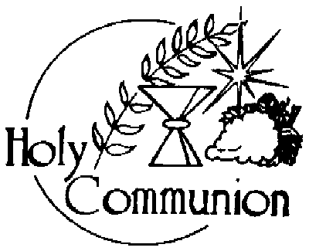
OUR LADY OF GRACE CHURCH
27 Centre St. Angus, ON L0M 1B0
Phone: (705) 424-1551
E-mail: olgracean@archtoronto.org
Web Site: https://olgracean.archtoronto.org

2026 First Holy Communion Preparation

Congratulations on starting your journey to receiving the Sacraments of
First Reconciliation and First Holy Communion. Beginning this month there will be mandatory meetings for your child plus one parent.

Mandatory Meeting Dates

- Saturday, October 18th @10:00am
- Saturday, November 22nd @10:00am
- Saturday, December 13th @10:00am – First Reconciliation
- Saturday, January 17th @10:00am
- Saturday, February 21st @10:00am
- Saturday, March 28th @10:00am
- Saturday, April 11th @10:00am

First Holy Communion Dates

- Saturday April 18th @ 5:00pm
- Sunday April 19th @ 10:00am/12:00pm
- Saturday May 2nd @ 5:00pm
- Sunday May 3rd @ 10:00am/12:00pm

*Dates are first come first served

